1. Log into your aws account first
2. Select roles

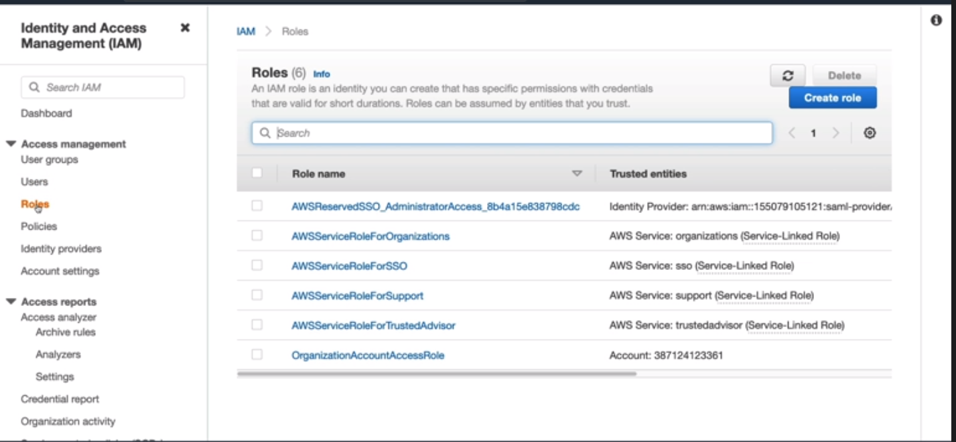
3. Now click on “Create Role”

4. Under Select trusted entity ( Roles for different Services, Accounts, Web Identity)

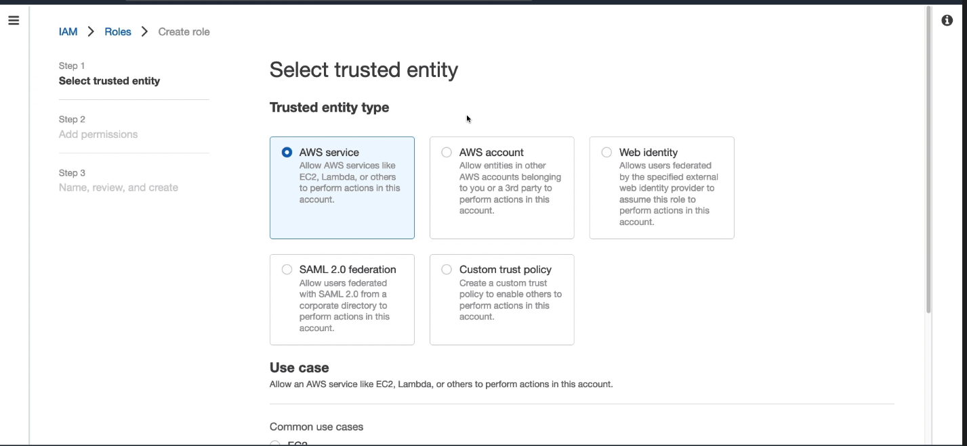

Common Use case is: 1. EC2, 2. Lambda

Now click next

5. Add Permission Policies.

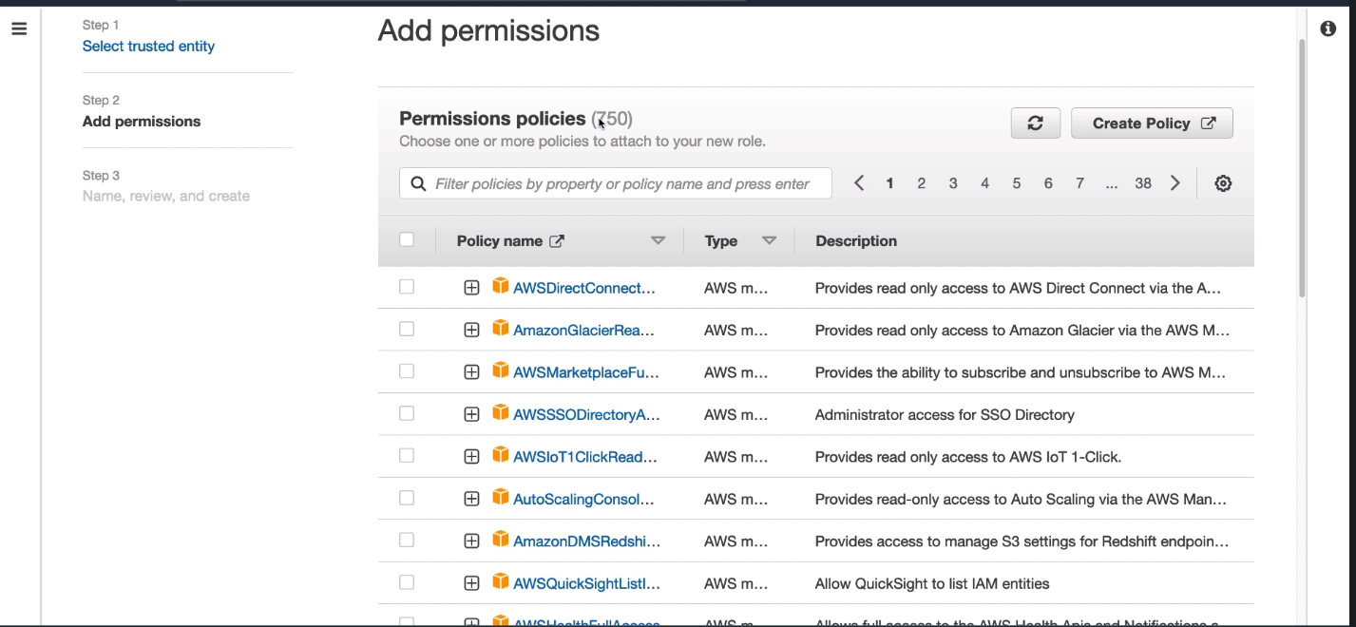

6.Allow IAM read only Access (Example in my case)

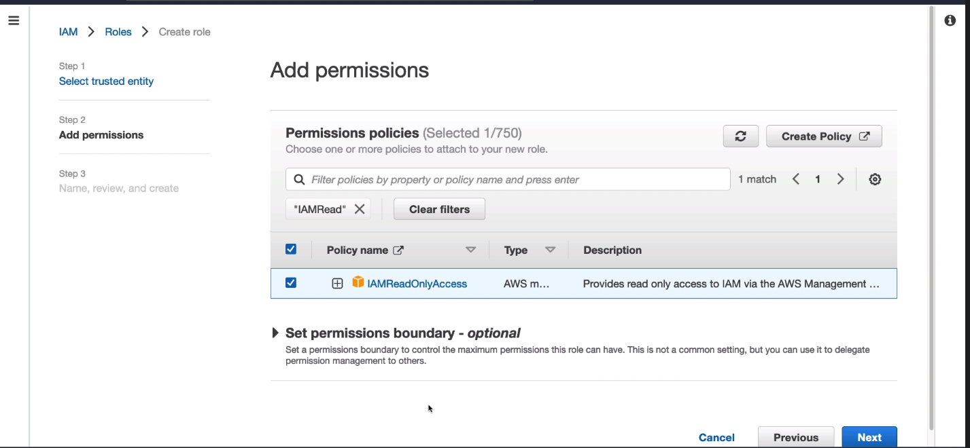

7.Click Next and Name the role you desire

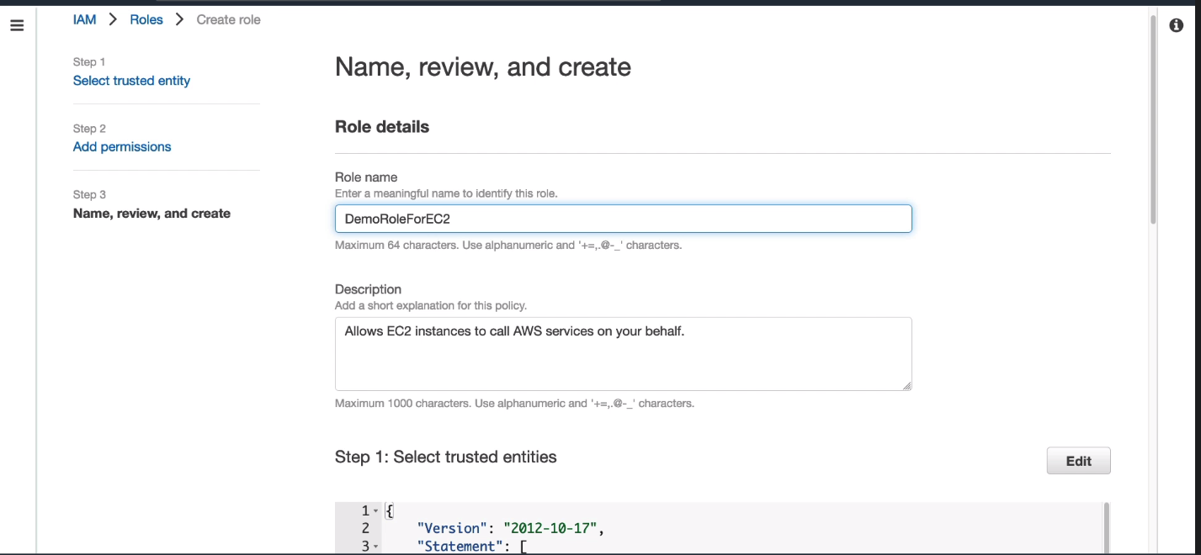

8. You can view the permission here

